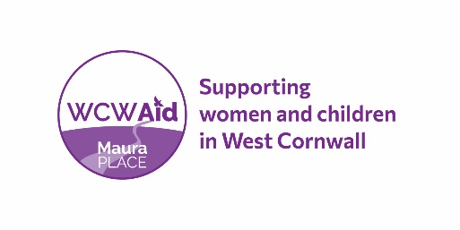
Helpline and Well- Being Worker Job Description

Hours: 25 hours per week – Mon – Fri 10.00 am – 3.00pm
Location: Based at WCWA Community Premises – Maura Place, Penzance
Salary: £15,526 - £17,251
Reporting to: Community Services Manager
West Cornwall Women’s Aid is a charity supporting women and children in West Cornwall and the Isles of Scilly. Our specially trained team offers a range of services to women who are experiencing domestic abuse and/or sexual violence or have done at any time in their lives, including childhood abuse.
The Helpline and Well-Being Worker will work as part of the Community Services team to deliver high-quality, empowering, emotional and practical support to women.

Key Responsibilities

To support Helpline line volunteers and take responsibility for answering calls in their absence.

To undertake risk assessments and devise safety plans alongside service users, directly or with volunteers.

Provide risk assessed support to be delivered; via telephone, Zoom, face to face at WCWA premises dependent on client preference and assessment.

To provide practical and emotional support to clients living in the community, who have experienced abuse at some time in their life.

To promote and support community group activities.

To refer high risk clients to IDVA service and MARAC as appropriate.

To assist and support clients to access specialist services to improve outcomes where possible.

To advise clients on issues relating to good mental health, managing anxiety, well-being and self-help practice, related risk, and harm.

To work with specialist service providers to increase accessibility for our clients to their services.

To ensure the completion of Empowerment Star assessments with each client and input data and case notes on WCWA data base in conjunction with the Community Services Manager.

Developing Best Practice
Attend and actively participate in WCWA operational meetings.
Together with the WCWA team, develop and deliver training sessions to WCWA staff and external agencies.

General
Adhere to WCWA Policies and Procedures at all times.

Cover for other members of the team as necessary.

Be proactive in reviewing and evaluating own performance and identifying and acting upon areas for improvement and development.

This job description covers the current range of duties and will be reviewed from time to time. WCWA aim to reach agreement on changes but if agreement is not possible WCWA reserves the right to change this job description.

Benefits
WCWA offers a variety of exciting opportunities to learn, develop and grow in your career. We recognise the value everyone brings to the organisation to achieve our aims and are dedicated to developing and rewarding our staff.
Benefits include:
- Competitive pay and holiday entitlement.
- Employer contribution pension scheme.
- Supportive and inclusive working environment.
- Access to a counselling service for employees and members of their immediate family.
- Access to external supervision to discuss personal or emotional responses to traumatic or difficult cases, to ensure emotional and psychological wellbeing.
- Professional and personal development through training opportunities.

Special Conditions
All posts at WCWA are subject to continuation funding.

An enhanced Disclosure Barring Service (DBS) certificate will be required for this role.

WCWA is committed to equality, diversity and inclusion and welcomes applications from all sections of the community. However, this post is restricted to women due to the nature of the role. The Occupational Requirement under Schedule 9 (part 1) of the Equality Act 2010 applies.

July 2022

